Campus Guide

**Submitted by Group:GC18**

**Nikunj Tyagi - University Roll No: 2100290140097**

**Rohit Sharma - University Roll No: 2100290140113**

**Harsh Sharma - University Roll No: 2100290140067**

# Session: 2022-23(4th Semester) Under the supervision of

**Mr. Praveen Kumar Gupta**

**Associate Professor**

# KIET Group of Institutions, Delhi-NCR, Ghaziabad



## DEPARTMENT OF COMPUTER APPLICATIONS

**KIET GROUP OF INSTITUTIONS, DELHI-NCR, GHAZIABAD-201206**

(April 2023)

# ABSTRACT

The Campus Guide project is all about the recreational camping activities done at the various tourist places. It also allows user to post comment, Feedback as well as the related pictures of the respective places. It is basically a camping site through one camping that place and know about the camping place, see the related picture and also sign up to comment and one can also post the cost queries.

# TABLE OF CONTENTS

1. Introduction
2. Literature Review
3. Project Objective
4. Technologies Used
5. Hardware requirement and Software requirement
6. Modules Description
7. Reports
8. Gantt Chart
9. References

# INTRODUCTION

The Camp Guide project is all about the recreational camping activities done at the various tourist places. It also allows user to post comment, Feedback as well as the related pictures of the respective places. It is basically a camping site through one camping that place and know about the camping place, see the related picture and also sign up to comment and one can also post the cost queries.

Features:

• Authentication: User login with username and password o Admin sign-up with admin code

• Authorization: One cannot manage posts and view user profile without being authenticated

• One cannot edit or delete posts and comments created by other users

• Admin can manage all posts and comments Manage campground posts with basic functionalities:

• Create, edit and delete posts and comments

• Upload campground photos

• Display campground location on Google Maps and Search existing campgrounds

• Manage user account with basic functionalities:

• Password reset via email confirmation (disabled)

• Profile page setup with sign-up

• Flash messages responding to users' interaction with the app

• Responsive web design

# LITERATURE REVIEW

**Related Things:**

Camping with Camp Ground allows you to see how the locals really live in certain places. Often, people live off the grid and immersed in nature. This is a very in-depth experience where you can see natural beauty every day and learn about simpler living first hand from locals. When you go camping, you often live in a communal space with locals or other volunteers. This allows you to form new bonds and friendships with your peers. You can trade stories and travel advice. You grow and learn together. You can have a more intimate experience with the people around you and discover more about different cultures in the process. Camping is the best way to create a deep connection with a foreign land because you are living outside, with few boundaries. If you love nature and want to step outside of your comfort zone, an adventurous, hands-on volunteer camping experience with World packers is the way to go.

### Front-End Development

### A front-end dev takes care of layout, design and interactivity using HTML, CSS and JavaScript. They take an idea from the drawing board and turn it into reality. What you see and what you use, such as the visual aspect of the website, the drop down menus and the text, are all brought together by the front-end dev, who writes a series of programmes to bind and structure the elements, make them look good and add interactivity. These programmes are run through a browser.

### Back-End Development

### The backend developer engineers what is going on behind the scenes. This is where the data is stored, and without this data, there would be no frontend. The backend of the web consists of the server that hosts the website, an application for running it and a database to contain the data. The backend dev uses computer programmes to ensure that the server, the application and the database run smoothly together. This type of dev need to analyse what a company’s needs are and provide efficient programming solutions. To do all this amazing stuff they use a variety of server-side languages, like PHP, Ruby, Python and Java.

### Motivation

### A great way to immerse yourself in a new country is by camping with Worldpackers. We have lots of camping experiences available where travelers can live in a foreign country while getting up close and personal with the natural world. We have work exchanges that include camping all over the globe, so you can volunteer in a country that intrigues you. Camping is especially perfect if you are an adventurous soul or a nature lover. Volunteering in cities and working in hostels or hotels is great for those who want a bit of comfort. But for those who want to venture off the beaten path and try a more spontaneous and wild volunteer experience, camping is the way to go. We envisage this product can truly reach the objectives with the rapid popularization of tablets.

* 1. **Problem Statement**

Due to the vast number of camping sites spread worldwide, it is very difficult to get to know the quality of a camping ground and the services provide at the camping sites. Camp guide is one such website that provides all the information regarding a camping sites. Camp guide provides us with reviews and ratings provided by the users and other services offered at the camping sites.

### Objectives

### In this project, we are providing Camping areas available around the world. people are not getting proper information about the camping area i.e its opening time, closing time, Any stay available near the camping area, how much it will cost per person, and working.

# PROJECT OBJECTIVE

In this project, we are providing Camping areas available around the world. people are not getting proper information about the camping area i.e its opening time, closing time, Any stay available near the camping area, how much it will cost per person, and working.

# TECHNOLOGIES USED

**Java Script:** –

JavaScript is an object-based scripting language that is lightweight and cross-platform. JavaScript is not compiled but translated. The JavaScript Translator (embedded in browser) is responsible to translate the JavaScript code. JavaScript is among the most powerful and flexible programming languages of the web. It powers the dynamic behavior on most websites, including this one.

It is mainly used for:

• Client-side validation

• Dynamic drop-down menus.

• Displaying data and time.

• Displaying popup windows and dialog boxes (like alert dialog box, confirm dialogbox and prompt dialogbox).

• Displaying clocksetc.

**MongoDB:**

MongoDB is a document database with the scalability and flexibility that you want with the querying and indexing that you need document database with the scalability and flexibility that you want with the querying and indexing that you need.

**CSS**

**What Is CSS?**

• CSS stands for Cascading Style Sheets.

• CSS describes how HTML elements are to be displayed on screen, paper, or in other media .

• CSS saves a lot of work. It can control the layout of multiple web pages all at once.

• External stylesheets are stored in CSS files.

• CSS describes how HTML elements should be displayed.

• CSS Saves a Lot of Work! The style definitions are normally saved in external .css files.

• With an external stylesheet file, we can change the look of an entire website by changing just one file!

• CSS can be either external or internal.

**HTML:**

Introduction

HTML (HyperText Mark-Up Language) is what is known as a "mark-up language" whose role is to prepare written documents using formatting tags. The tags indicate how the document is presented and how it links to other documents. The World Wide Web (WWW for short), or simply the Web, is the worldwide network formed by all the documents (called "web pages") which are connected to one another by hyperlinks. Web pages are usually organised around a main page, which acts as a hub for browsing other pages with hyperlinks. This group of web pages joined by hyperlinks and centred around a main page is called a website.

# HARDWARE & SOFTWARE REQUIREMENTS FOR DEVELOPING THE PROJECT

## Hardware Requirements

|  |  |
| --- | --- |
| **S. N.** | **Description** |
| 1 | PC with 10 GB or more Hard disk. |
| 2 | PC with 2 GB RAM. |
| 3 | PC with core i3 or above processor. |

**Software Requirements**

|  |  |  |
| --- | --- | --- |
| **S. N.** | **Description** | **Type** |
| 1 | Operating System | Windows 10 or 11 or Ubuntu  18.04 or above |
| 2 | Back End | JavaScript, Node.js, Mongo Db |
| 3 | Front End | HTML, CSS, Bootstrap |
| 4 | IDE | VS Code |
| 5 | Browser | Chrome, Firefox, Edge |

# FEATURES

# Authentication : User login with username and password. Admin sign-up with admin code.

# Authorization : One cannot manage posts and view user profile without being authenticated.

# One cannot edit or delete posts and comments created by other users.

# Admin can manage all posts and comments

# Posts can be sorted in many ways – according to reviews, time, trending.

# REPORTS

This project will have the following reports:

* + Comparison of accuracy of various ML models used for intent classification
    - Logistic Regression Model
    - Gaussian Naive Bayes Model
    - K-Nearest Neighbours (KNN) Model
    - Recurrent Neural Network (RNN) Model
  + Various sources of Questions collection
    - Questions from Google searches
    - Questions from popular admission websites
    - Questions collected from survey through Google Forms

# FLOW CHART

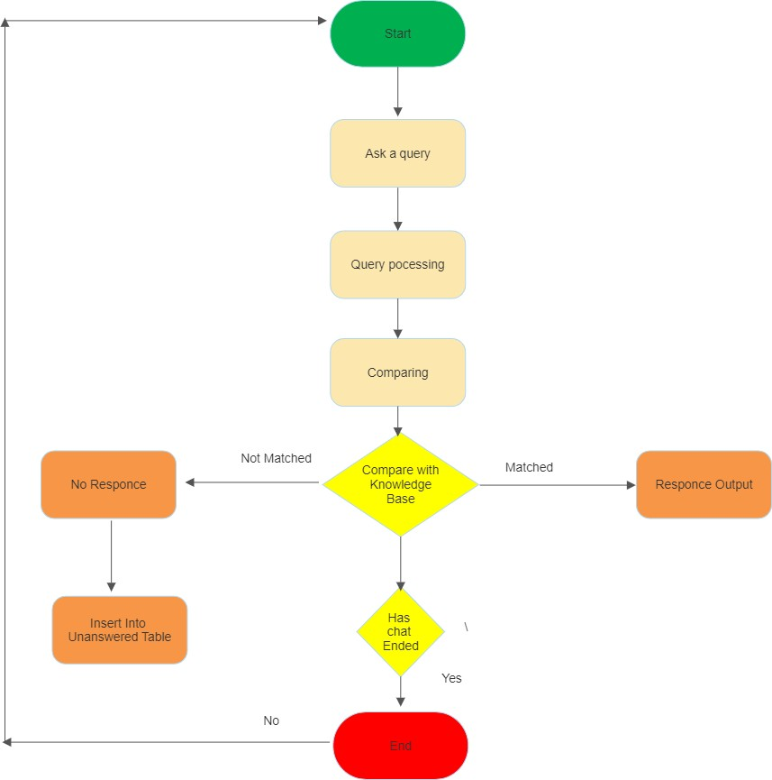

**GANTT CHART**

14-Mar24-Mar 03-Apr 13-Apr 23-Apr 03-May13-May23-May Feasibility Study and requirements gathering

Research and Study

Intent classificaition using NJS

HTML, CSS, BOOTSTRAP

JavaScript

Node.ls

Database using Mongo DB

API creation Deployment

# REFERENCES

1. <https://docs.mongodb.com/>

2. <https://expressjs.com/>

3. <https://www.javatpoint.com/html-tutorial/>

4. <https://www.javatpoint.com/css-tutorial/>

5. <https://www.javatpoint.com/javascript-tutorial/>

6. <https://www.javatpoint.com/reactjs-tutorial/>

7. <https://www.javatpoint.com/dbms-tutorial/>

8. <https://www.javatpoint.com/mongodb-tutorial/>

9. <https://www.javatpoint.com/nodejs-tutorial/>

10.<https://nodemailer.com/about/>

11.<https://stackoverflow.com/>

12.JavaScript and JQuery: Interactive Front-End Web Development Book by Jon Duckett

13.HTML & CSS: Design and Build Web Sites Book by Jon Duckett